SEGY eShopper Key Abstractions and Architecture Design

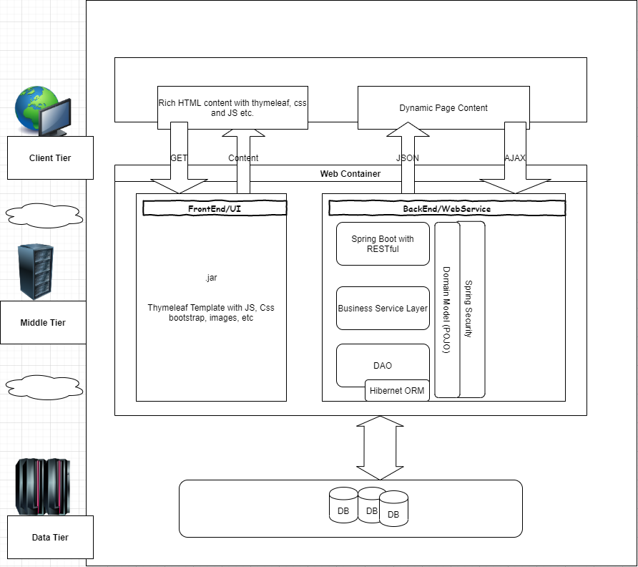

Key Abstractions

* Login
* Registration
* Role
* ProductCategory
* Product
* Checkout
* ShoppingCart
* Payment
* Order